

School Of Mechanical & Manufacturing Engineering, NUST

Department of Mechanical Engineering

CS-114 - Fundamental of Programing

Lab Manual # 02

**Course Instructor:** Dr Jawad Khan

**Lab Instructor:** Muhammad Affan

MUHAMMAD MUZAMMIL RIAZ

## Student Name:

**467817**

**CMS ID:**

**DATE:** 02/10/2023

1. Write a C++ program to calculate distance between two points. The values should of coordinates should be input by user.

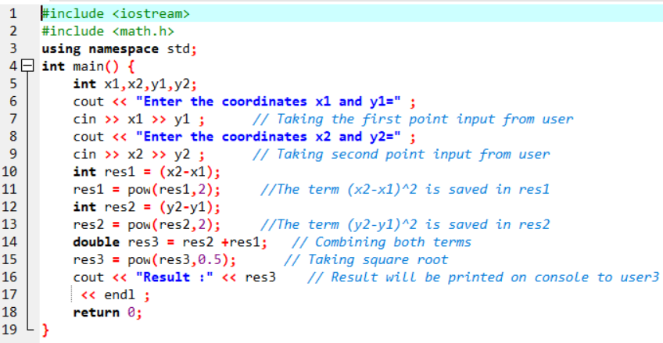

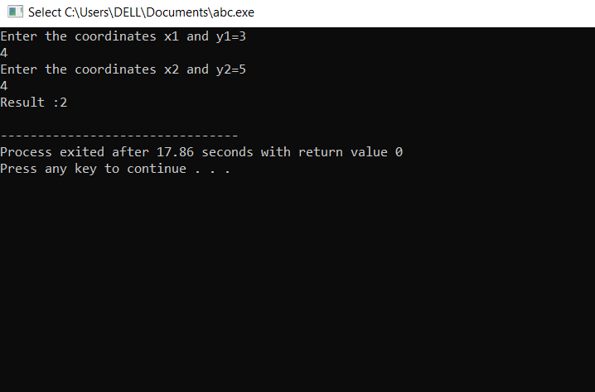

2. Write a code in C++ to take length from user in centimeter and convert it into meter and kilometer.

3. Write a code in C++ that takes values of a and b from the user and displays result of polynomial 𝑎 2 + 2 𝑎𝑏 + 𝑏 2.

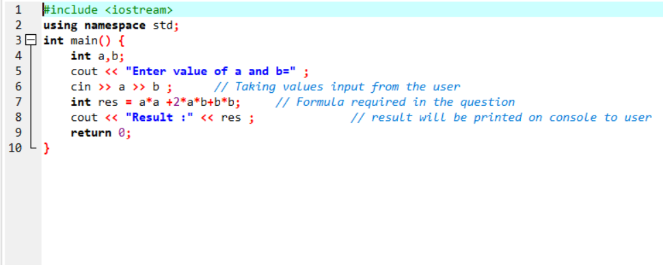

4. Write a program in C++ to convert temperature in Fahrenheit to Celsius.

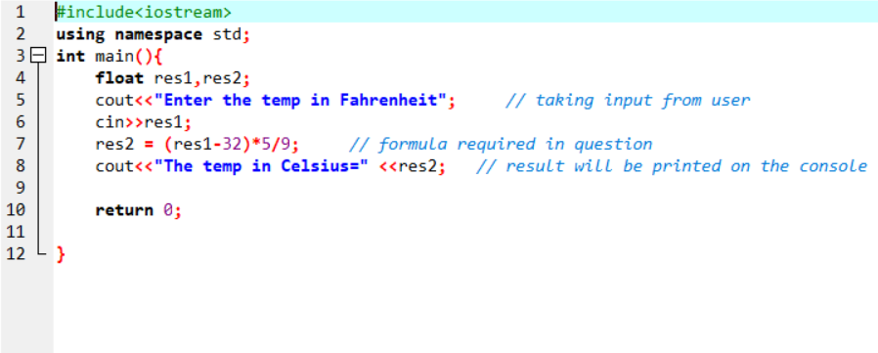

4. Write a program in C++ to convert temperature in Fahrenheit to Celsius.



